Convince Your Manager – ISM World 2023
Ready to get out there and connect with other procurement professionals, suppliers and more in person? ISM World 2023 has you covered.
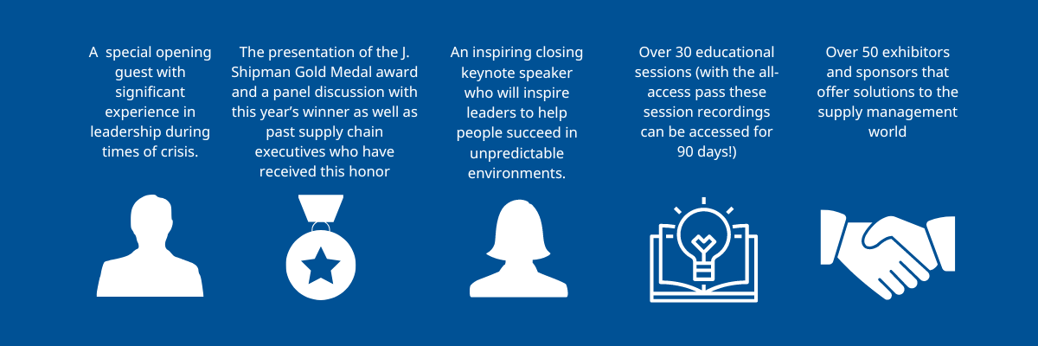
Here are some discussion points when speaking with your manager:
- Attending conference is a compact way to accomplish focused learning on practical and strategic topics impacting procurement today. You will walk away with tools to immediately implement on the job.
- You can expand your network and learn from fellow practitioners experiencing similar challenges and sharing their journey toward success
- You can meet with over 50 suppliers from diverse suppliers, new technology, risk management and logistics solutions
- (If you are certified) Attending conference is a great way to continue your education and earn CEHs toward your recertification

Still need help getting approval to attend? Use our Convince Your Manager template to advocate for the opportunity to attend ISM World 2023 scheduled for May 7-10, 2023 just minutes from the Dallas/Ft. Worth airport in Grapevine, Texas.
(DOWNLOAD THE SAMPLE LETTER) => https://620652.fs1.hubspotusercontent-na1.net/hubfs/620652/Annual%20Conference/Sample_Letter_ISMWorld23.docx
(LINK BACK TO MAIN CONFERENCE PAGE)

