Institute for Supply Management®
Chapter Website Reference Guide

August 2022

Table of Contents
Accessing the CMS Site 3
Updating Pages 3
Homepage Edits 5
Publishing 6
Website Images – uploading and publishing 7
Updating Links 10
Track History / Reverting Back 11
Adding a Video 12
Education Calendar 15
Adding Chapter Events 15
Event Components 15
Glossary 18
Epi CMS (EPI) 18
Preview Mode 18
Edit Mode 18
Cake Layer 18
Block 18
Page Tree 18
Icons 19
Photo Gallery 20
Turning Pages off (Archiving) 24
Superscripting Symbols ® ™ 25

A detailed user guide is available on EPiServer CMS by clicking on the “?” icon, located in the upper right-hand corner. This reference guide provides a quick overview of the typical task functions for updating your chapter website.

Accessing the CMS Site

Log-in link: chaptername.ismworld.org/episerver
- Log-in using your web admin credentials given to you.
  - Misplaced your online credentials? Please contact Mario Ballesteros at mballesteros@ismworld.org to reset your login.
- After a successful login, you will land on a blank homepage – click the small squares (top-left corner) and select CMS.
- Navigation within CMS and to other parts of the Episerver platform is done via the top menu

Updating Pages
The toolbar and the panes in the Episerver edit view provide easy access to functions when working with content. When entering the edit view, you have the top menu and the toolbar at the top, and adjustable panes to
the left and right.
- Using the Page Tree icon on the left side panel, navigate to the page you want to update and click to edit.
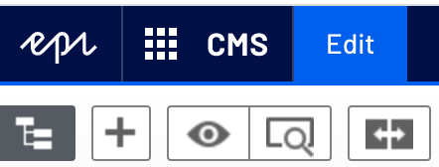
- By default, the page will open in Preview Mode.
Note: You can edit in this mode; however, there is also another view if you prefer.
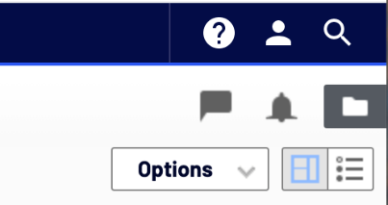
- The second edit option is to click the list icon – top-right corner of the page. This will launch the ‘Edit Mode’, Edit Mode where you edit things by using the input fields.
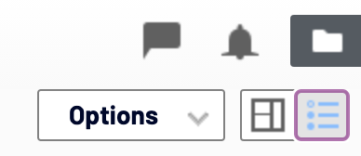

Homepage Edits
- You can modify any content on your website that is labeled with – CHAPTER. To do this scroll to and click on the section you want to change. The platform will either allow you to modify that section right on the page, or show you which section you need to edit, and allow you to click ‘Edit’.
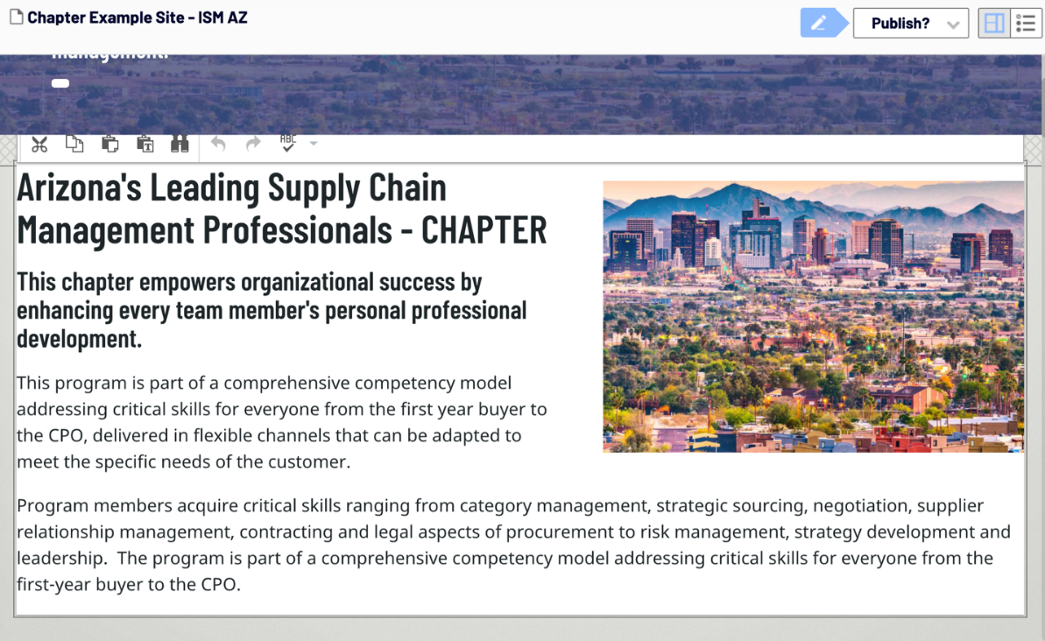

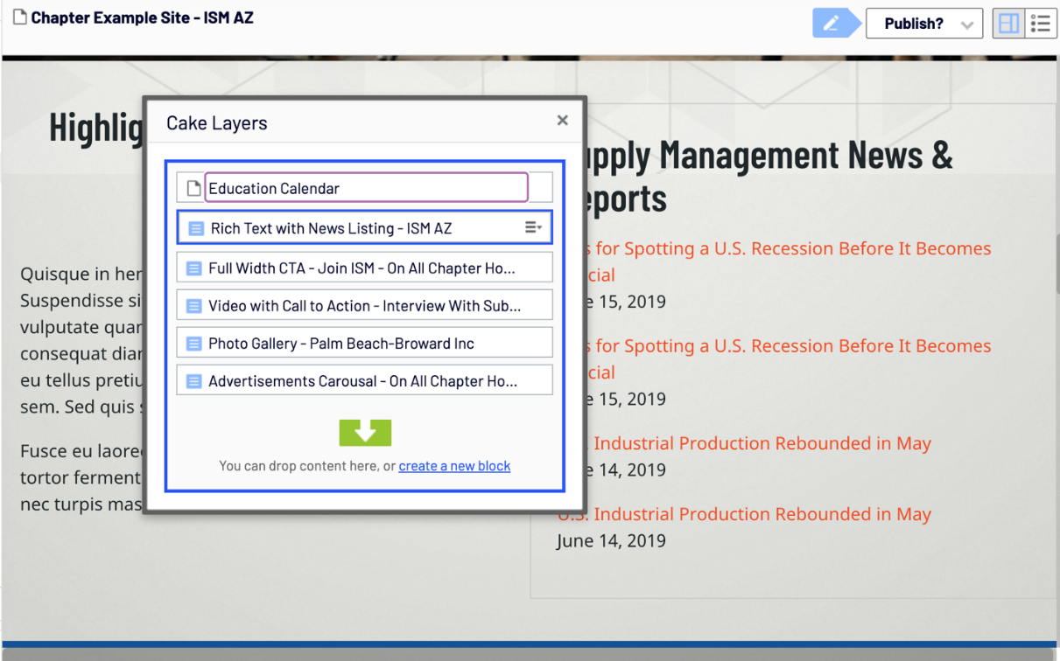

Presidents Message / Highlights
You can now edit this block as you would any other block on the website from your Homepage.
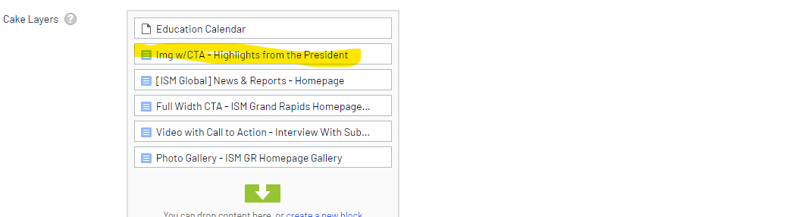

News & Reports – Homepage
This News & Reports block will come 100% from ISM Global. The articles in this block will update daily and be a constant source of new content on your homepage.

Publishing
- Once you make any change, the CMS auto saves. This prevents you from losing any work you’ve started if you were to accidently close your browser window.
  - You will know that you have made a change that is not currently published if the blue pencil appears next to the Publish button.
  - If you have made changes and not yet published and want to get back to the version that is published, click ‘Revert to Published’ in the screenshot below.
- If you have made a mistake and need to ‘revert back’ there is a way to see your pages version history. Instructions are noted below.
- Warning: Once you hit the publish button your changes are live on your website.
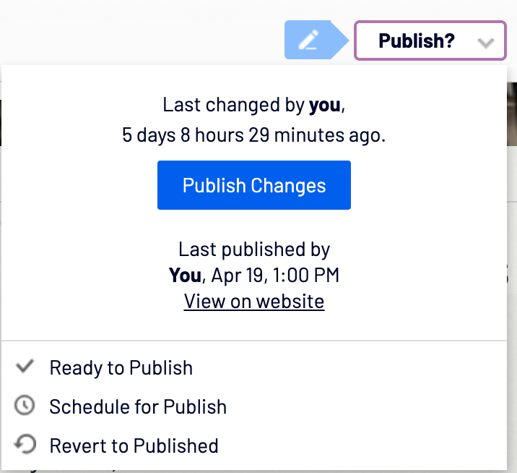

Website Images – uploading and publishing
Image files must be stored in the media library on the Media tab in the assets pane to be available in Episerver CMS.
- Navigate to the right sidebar by clicking folder icon located in the top right corner. This is where you are going to find images, documents (pdf, word etc.)
- Navigate to the Media Tab. The folders may differ from screenshots in this document, but you will see a ‘Images’ folder that will hold all website images. There are pre-set folders such as documents and images. Documents folder is for pdf files, word doc files etc. Member Only folder has pre-set access rights only for members.
  - Tips:
    - By default, your view of the screenshot below may differ. You may need to use the re-arrange tools to change the height of all of the different folders for easier viewing.
    - Click the icon and then click the thumb tack icon making the right sidebar sticky and it won’t go away.
    - Try not to upload images that are very large. Image sizes impact SEO and web page loading time. Try to keep images smaller than 700 pixels wide.
    - Image files REQUIRE alt text or the image cannot be used.
    - Documents REQUIRE a title or they cannot be used.
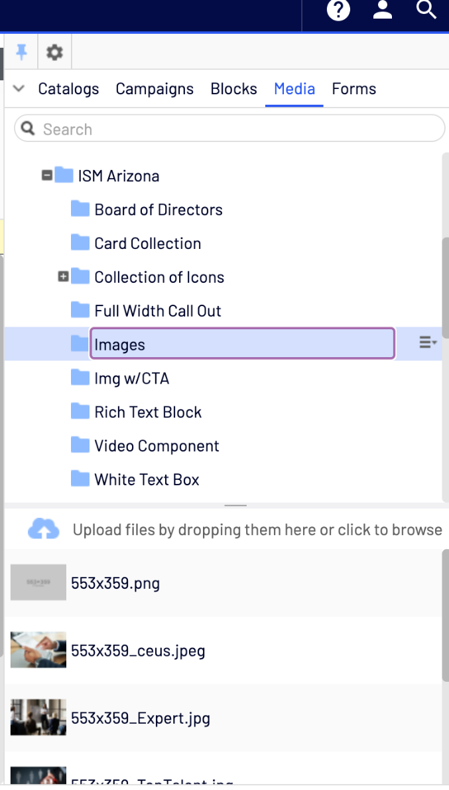
- You can either drag and drop new images into the images folder or click to upload.
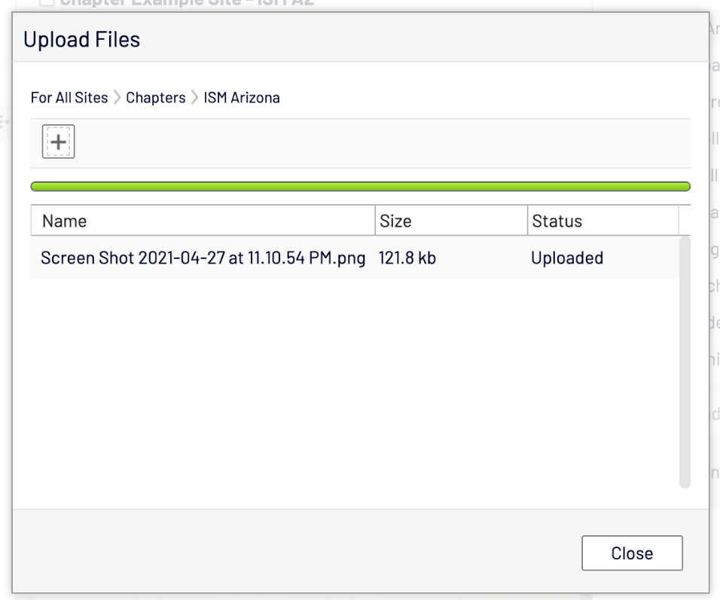
- Once it’s been uploaded, click Close. Wait, the image is not ready to be used yet!
  - You must make the image accessible to screen readers before the image be used.
- The CMS requires alt text for the image. Alt text on images is so that the image can be screen reader friendly for the visually impaired.
- To add alt text hover over your new image and click the list icon, click, and select edit.
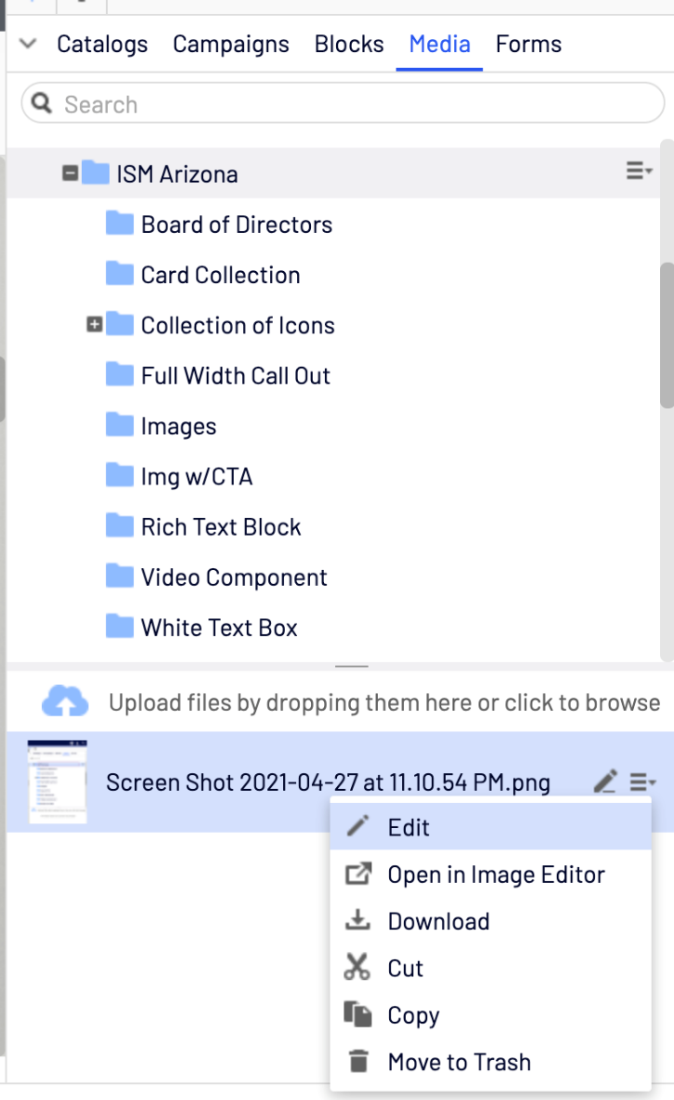

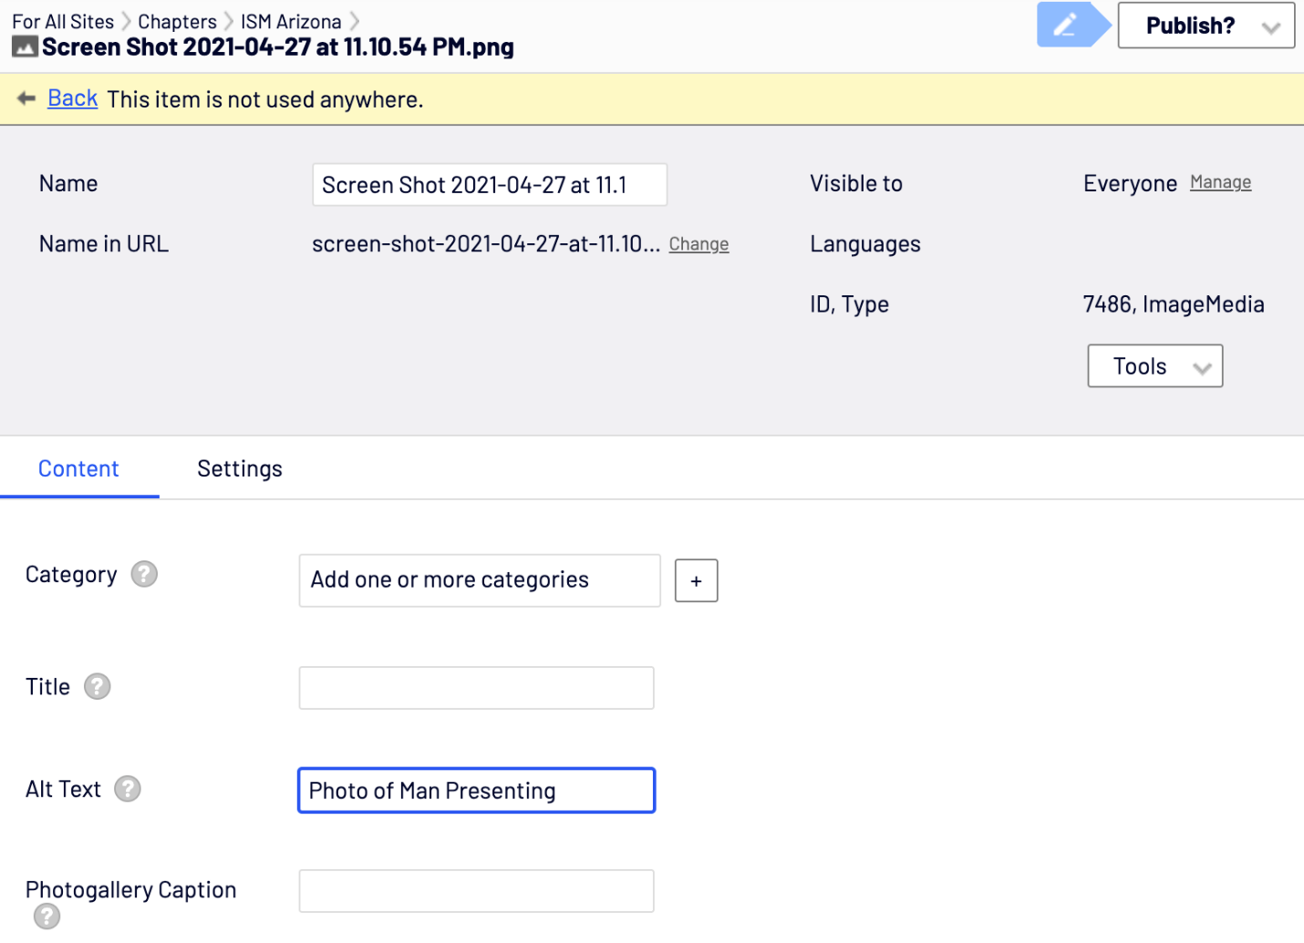
- Once your image has alt text you can publish it.
- Great! You’ve uploaded the image; now where did you want to use it?
- Go back to the page or block you wanted to add the image to.
- You can drag and drop your new image into the image field you wish to replace.
- Once your image is placed you can publish your image change and it will be live on your website.

Updating Links
- You can add or modify links by adding a URL and Link Text to a button field.
- Add a URL by clicking the three dots. A modal appears and you have link options.
  - Page: Another page on your website.
  - Media: Word Document, PDF, etc.
  - Catalog content: Education or Product pulling from Education Calendar.
  - Email: Put an email address here if you want the button to open a new email draft.
  - External Link: A link to a page that is outside of your website.
- Once you’ve added a URL and Link Text you can publish your change and the button will appear.
Example:
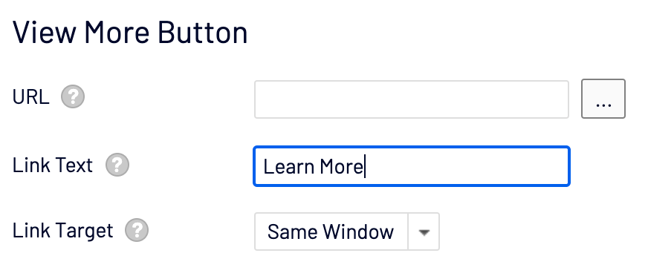

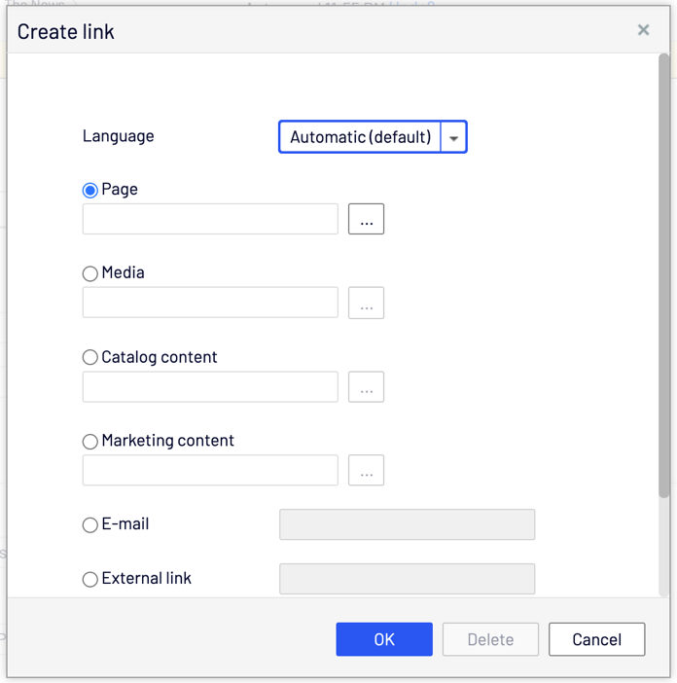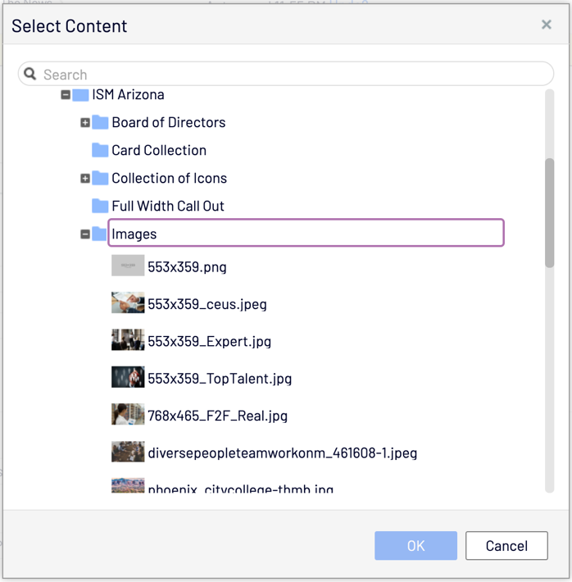

Track History / Reverting Back
- You can view the change log on blocks and pages. Click the rectangular / arrow icon.
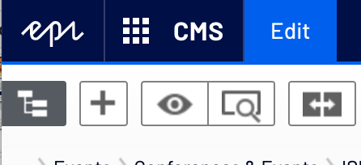
- Once you click the icon the Comparing tool pops up. Click ‘Previously Published’ drop down to view the change log.
- You can choose which version you want to go back to, and then copy over that version’s elements into the new version you are creating. Once all of the input fields are how you want, click Publish.
- You have now reverted back the elements you chose from a previous version.
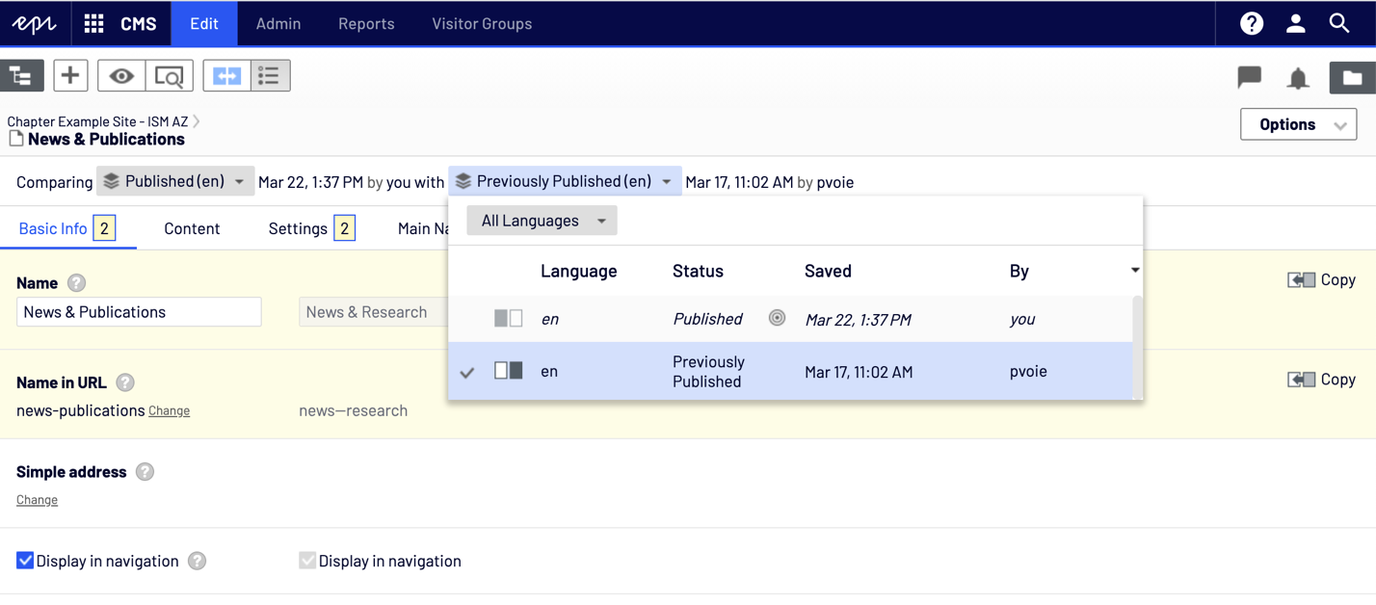

Adding a Video
- Any video uploaded to YouTube can be used on the website. All you need to know is the video’s ID.
  - Example: https://www.youtube.com/embed/IIz4J6vBlEE
- Keep the scripting that is already in the video box, and just replace the video ID at the end. The website will auto populate your YouTube video for you.
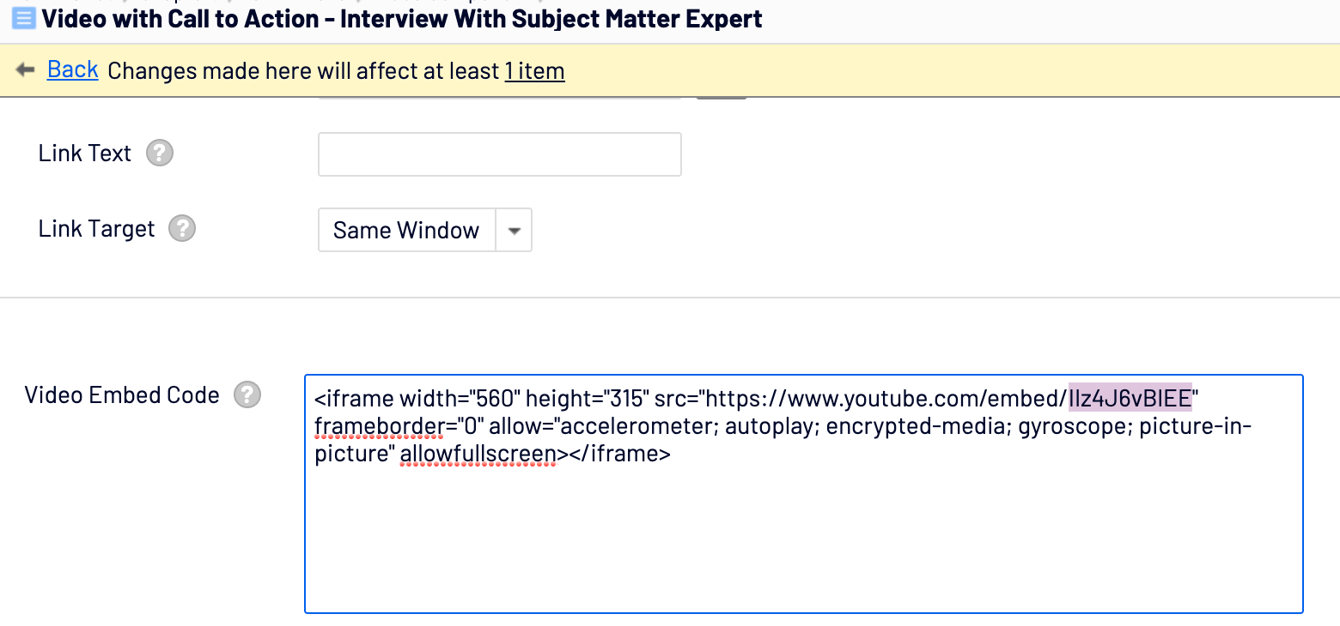

Education Calendar

Adding Chapter Events
- The content in the education calendar is populated by ISM Global and not editable through Epi CMS.
- The below form is available under the online chapter portal and should be filled out in its entirety and submitted to Mario Ballesteros of ISM Chapter Support for setup.
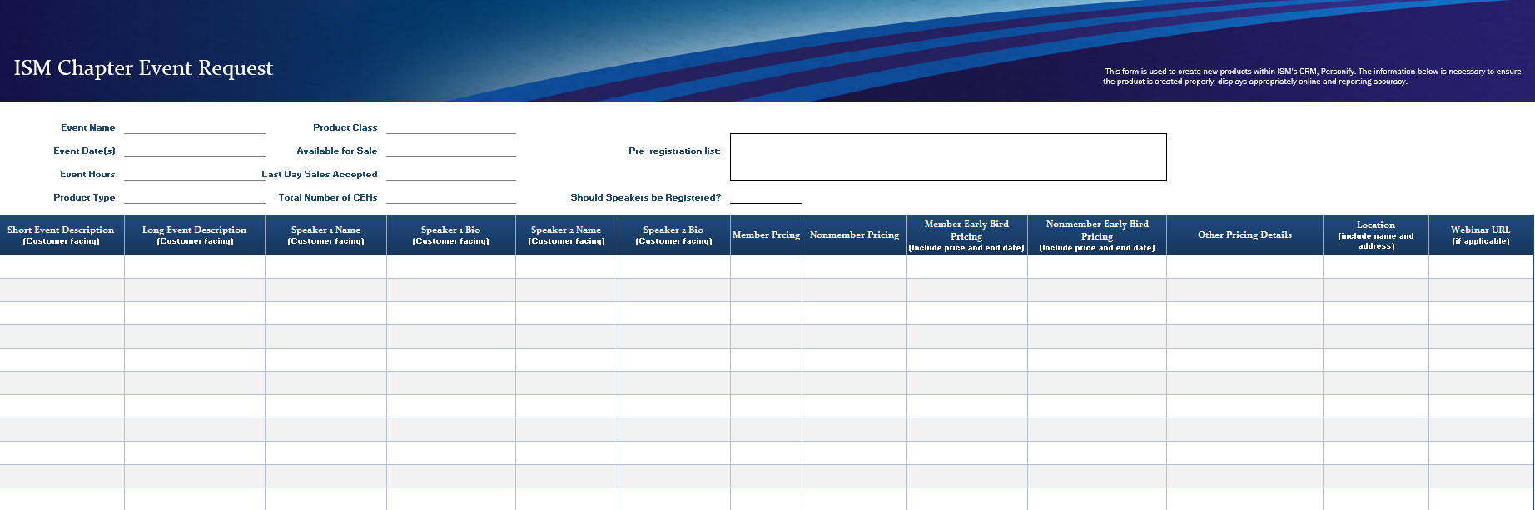

Event Components
- Event Name
  - This should be kept short and precise. It is visible to customers on the website, under MY ACCOUNT, on invoices and/or receipts. This will also be included on chapter reporting.

- Event Description
  - This is where you provide full details on what attendees should learn and/or expect from their participation. This only displays online as a product description.
  - Brief Description – the text highlighted below is where the brief description displays and is about 240 characters.
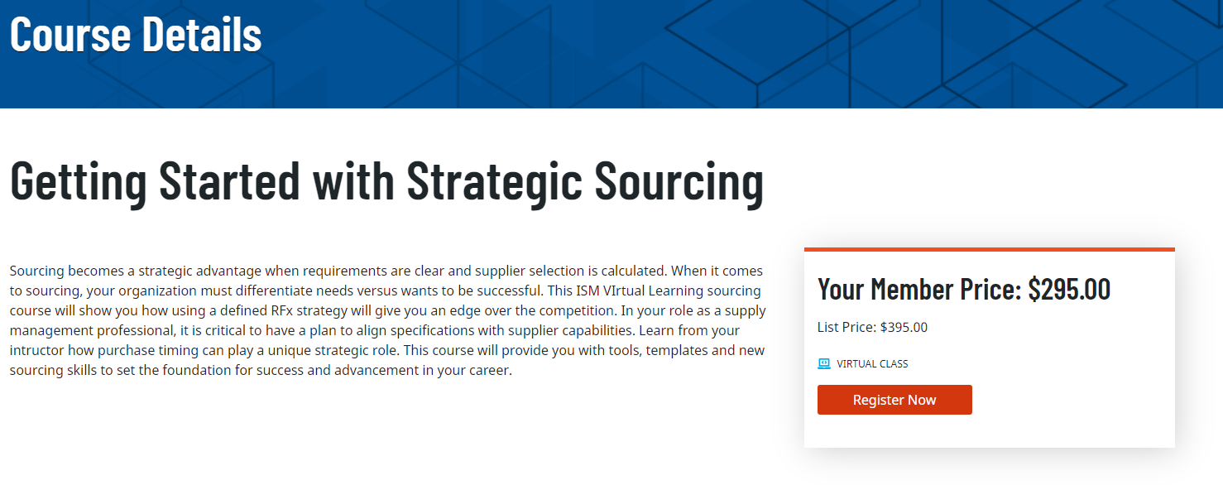

  - Long Description – The long description is the description under Additional Information on the product page and should be used for “formal” training versus monthly meeting and/or multi-day event.
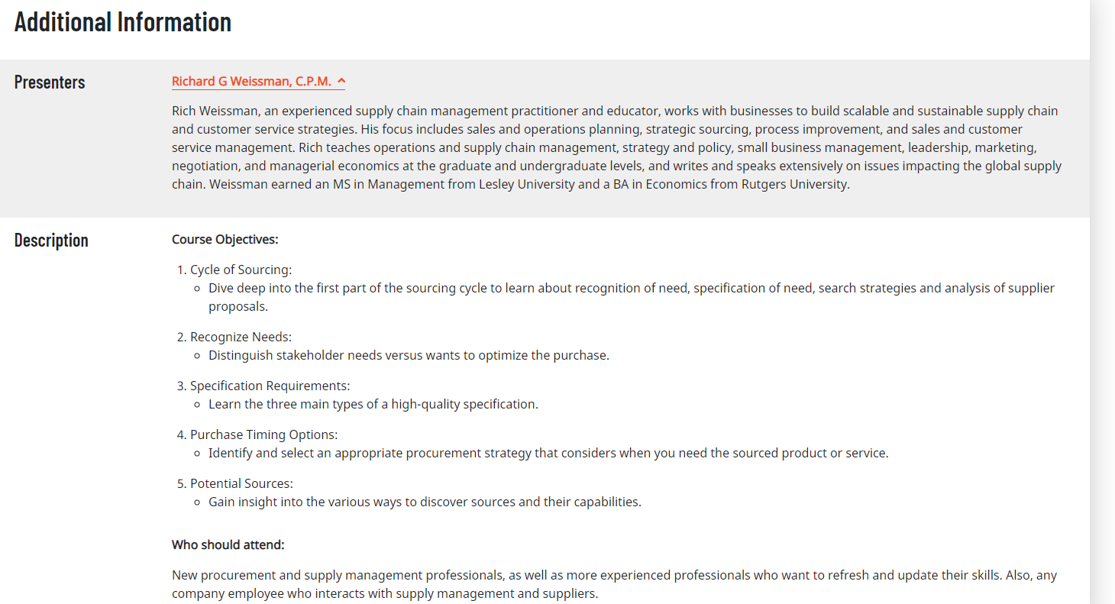

- Product Type
  - Meeting – most of your events will be classified as meetings. This is used when you want an event displayed in the education calendar to collect registrations.
  - Advertising – this type of product will not be visible on the website.
  - Exhibition – this is applicable for selling a booth for a multi-day event
  - Sponsorship – this sponsorship product type is applicable to event sponsors versus website advertisers.
- Product Class – sub-class of the meeting product type
  - Seminar – this is a face-to-face, classroom style training
  - Webinar – One-hour webinar with an external platform link
  - Conference – multi-day event with multiple speakers
  - Virtual Learning – this is a multi-hour virtual training
- Member and Nonmember Pricing – this displays online. Every product requires a member and nonmember rate unless the product is exclusive to members only. If you event has an early bird rate, please include that details in the separate column, along with, the date the early bird pricing expires.
- Rates and Pricing –These additional pricing options are not displayed online; however, they can be helpful for reporting purposes. Each rate listed below is an example and can be defined as complimentary or with a special rate. Rates and pricing are not used for marketing purposes.
  - Speakers
  - Chapter officers
  - Sponsor
  - Students/academics
  - Committee members
  - Award winners
  - VIP
- Available for Sale – this is asking for the date that the product should display online and/or the date the product should be available for sale.
- Last Days Sales Accepted – this is the last date that the event should be online, and registrations accepted.
- Event Hours
  - Event Day and Start Time – this detail displays online under Event Details
  - Event Day and End Time – this detail displays online under Event Details
  - Please include the time zone for every event
- Event Location – this displays online and should include facility name and address.
- Total Number of CEHs
  - Continuing Education Hours (CEHs) are defined as 1 CEH = 1 hour of education. Social events, fundraisers, etc. are not eligible for CEHS. This field displays online.
- Speaker name(s) and Bio(s) – this is submitted only if you would like this information displayed online. No photo necessary.

Glossary

Epi CMS (EPI)
This is the name of the content management system (CMS) that supports your website.

Preview Mode
This view shows web admins a preview of what the web page will look like without having to publish any changes to the public.

Edit Mode
Edit sections of the website using the input fields.

Cake Layer
“Blocks” or “Components” that make up a web page.

Block
Blocks are pieces of content that can be reused and shared between websites, while being maintained in one place only. Blocks are managed from the Blocks tab under the assets pane in Epi CMS, where you can create new blocks and organize them in folders. You can then utilize blocks by dragging them into the content area of Epi CMS pages.

Page Tree
By hovering over a page in the tree structure, information about the page appears, such as ID and page type. A set of page tree symbols provides additional information about the structure, below is a view of the most common. For a complete overview, please access the Epi CMS Editor User Guide.
The Root Page Start Page (chapter homepage) Published Page Draft Page

Icons
Hover over a button or field and a short tooltip appears.

Photo Gallery
Click the folder icon in the top right.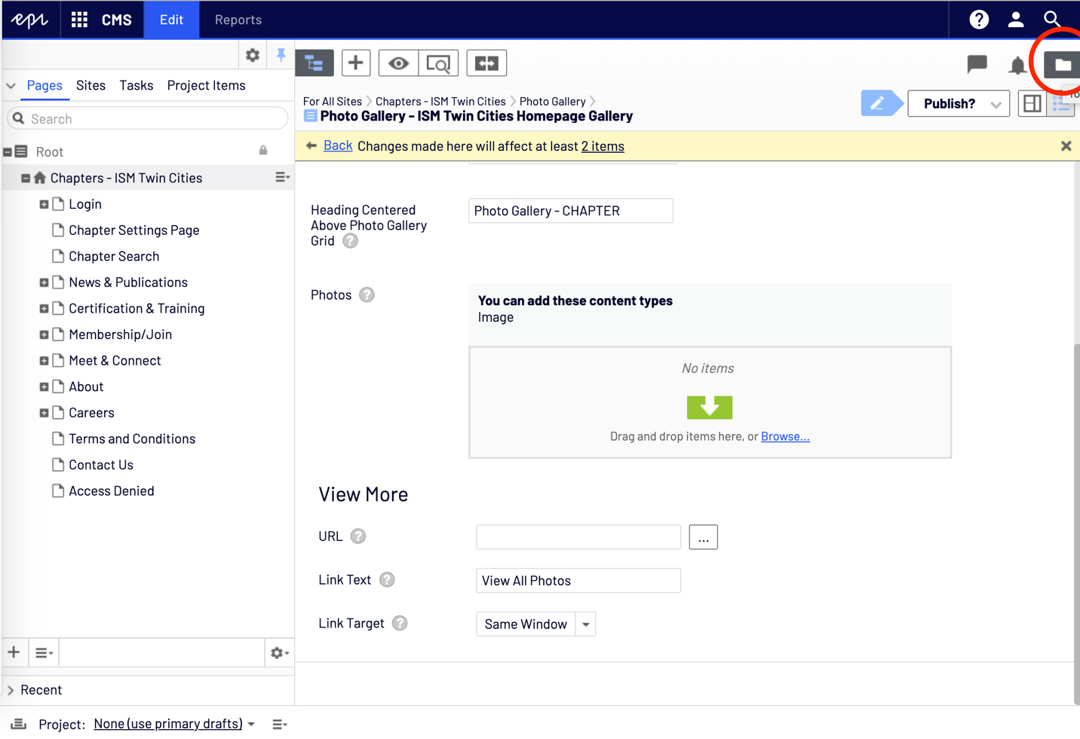
Click the thumb tack in to pin the right sidebar. This will help the sidebars from going away.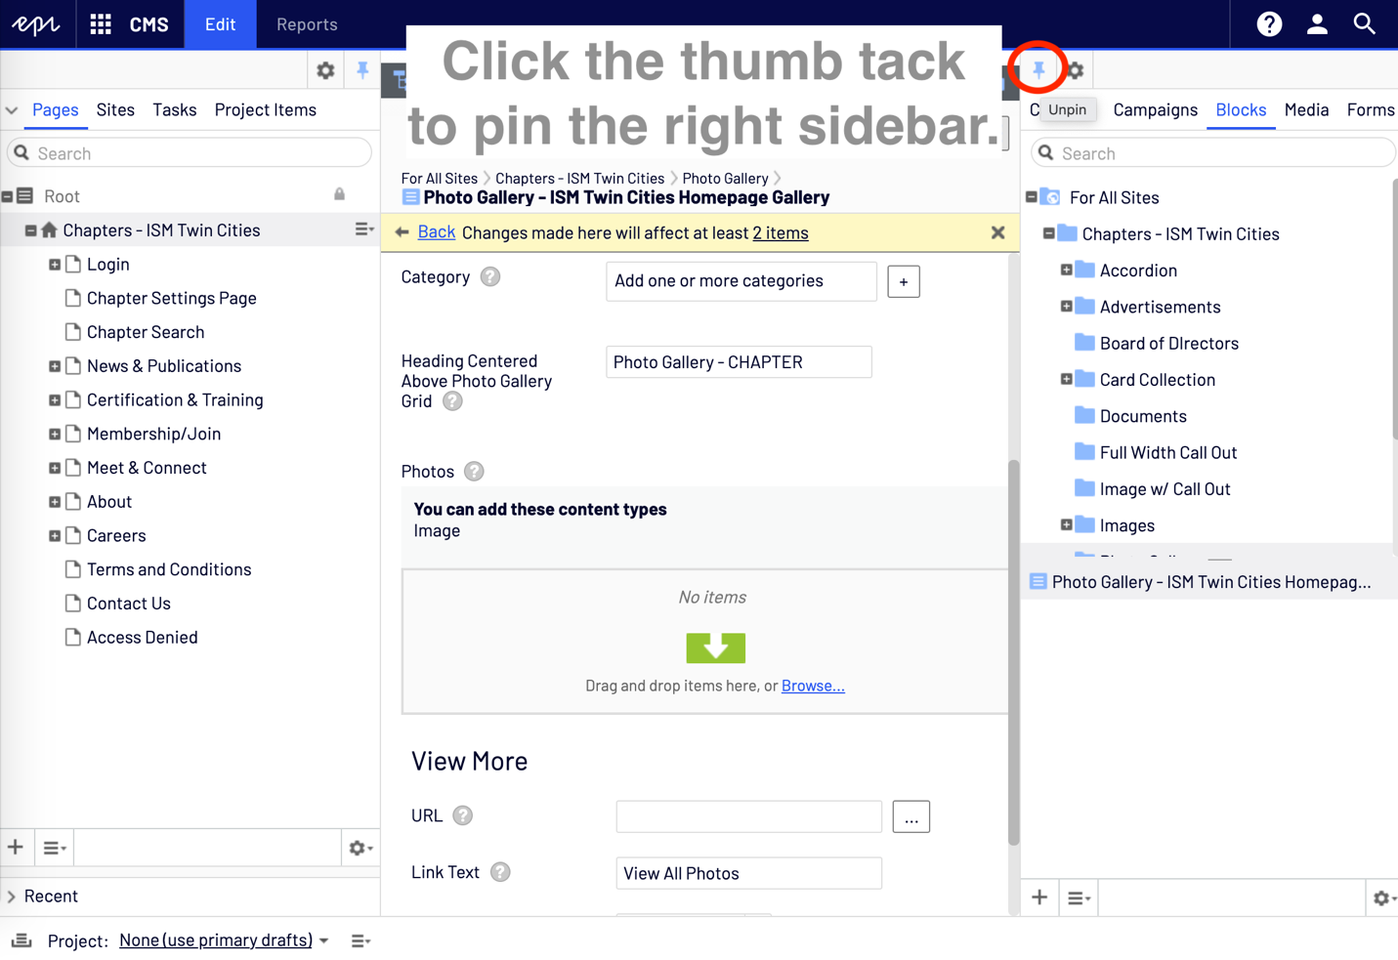
Click the media tab, then in the folders below click the Images folder. This is where you can Upload your images by dropping them or clicking to browse. 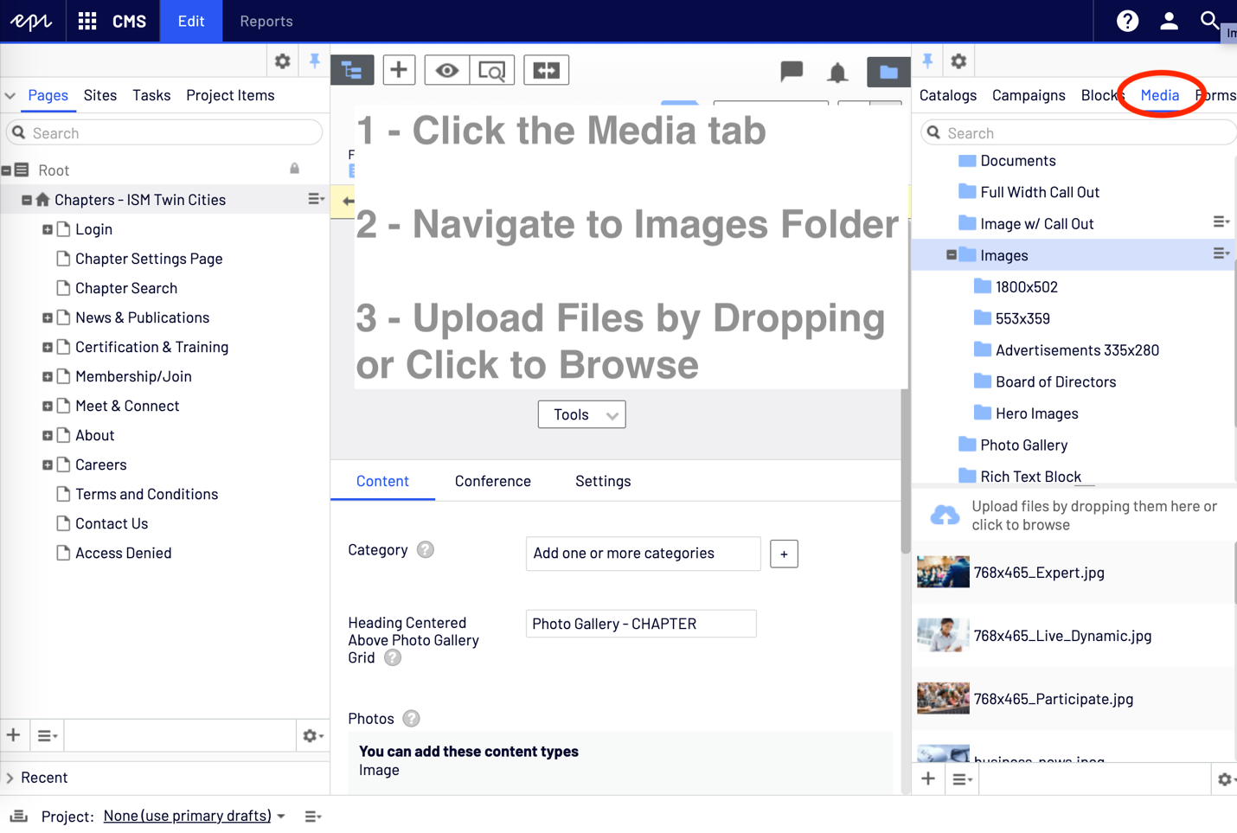
Once images for the Photo Gallery are published with descriptive text (alt text), drag and drop them into the centered area in the middle. Once all photos are uploaded, click Publish the block.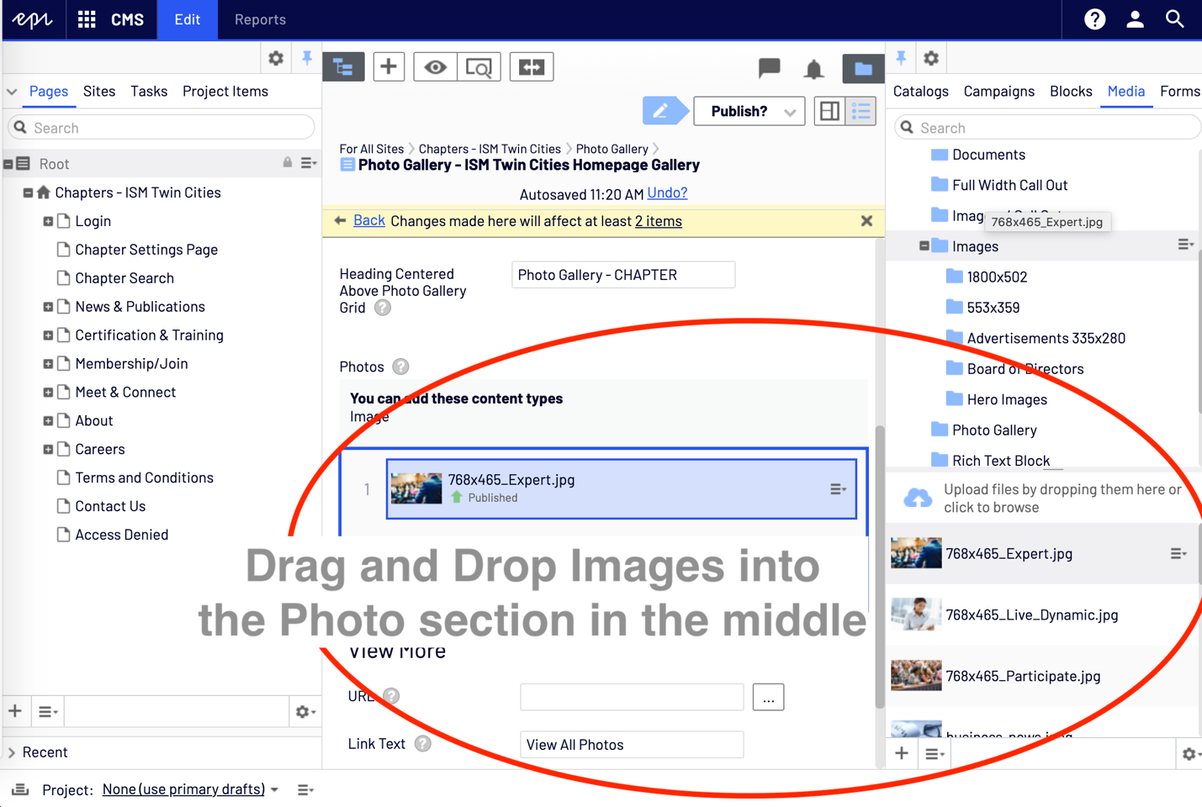

Turning Pages off (Archiving)
Tools > ‘Manage Expiration and Archiving’
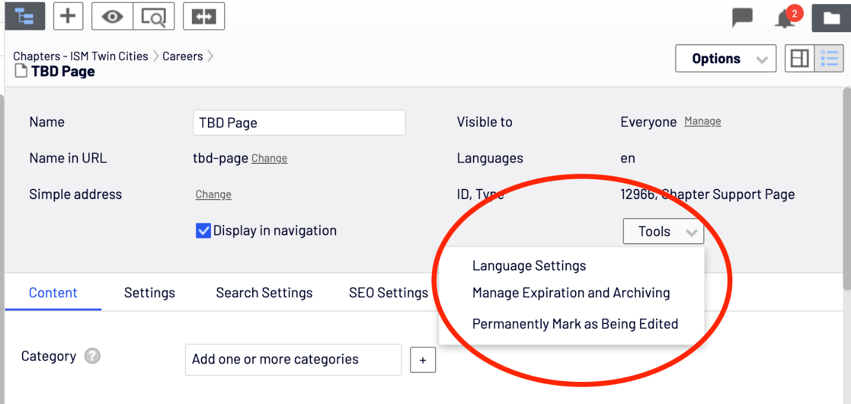

Options to Archive - Now or set a Expire date.
Do not select an Archive to location, this would move your sitemap around.
Click Save.
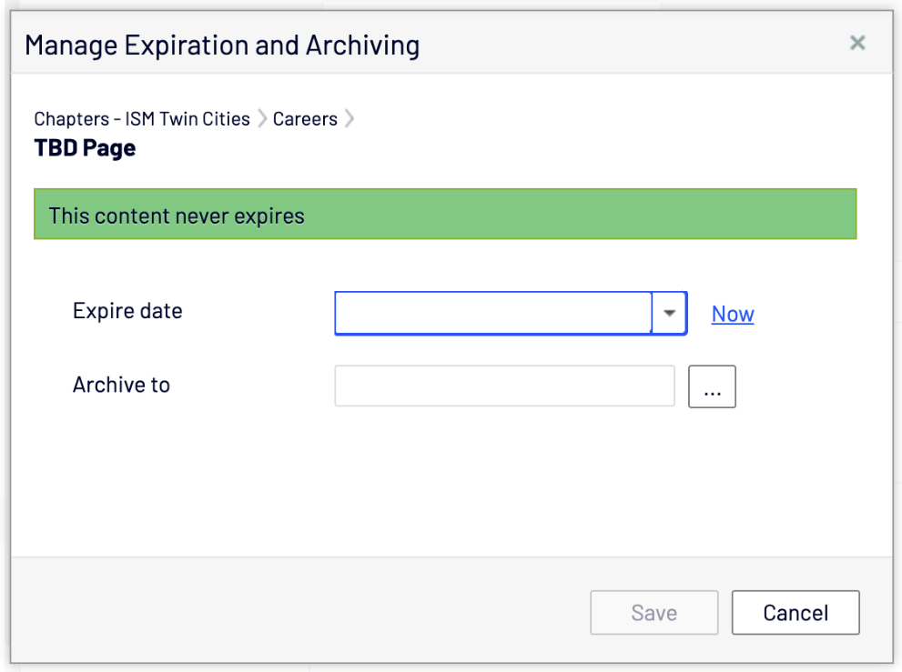

Superscripting Symbols ® ™
If there is a need for a registered, copyright or trademark symbol, here are a few suggestions:
- Copy and paste the symbol from an example.
- To superscript the symbol, you will need to look at the source code of the rich text block. Look for the <> symbol and click.
  - 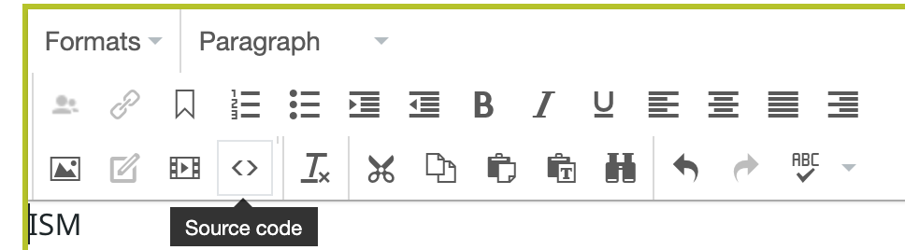
- To apply superscripting apply any of the examples below into the text.
  - <sup>™</sup>
  - <sup>®</sup>
  - <sup>©</sup>
  - 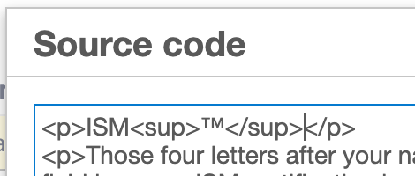
- After you click Ok, it should appear superscripted.
  - 